***Challenge 10***

**Challenge:**

**Add JS object to save the post title and body**

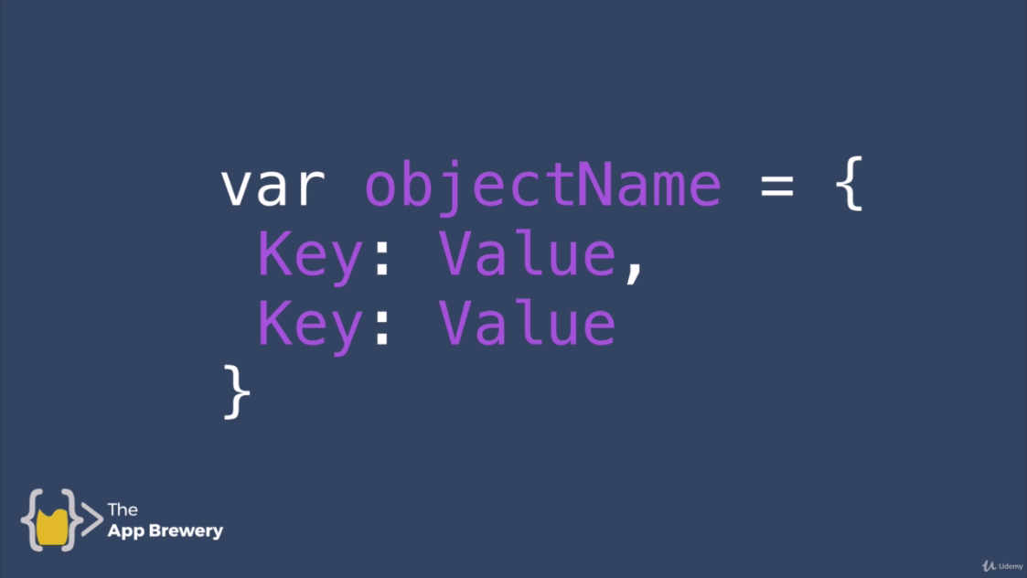

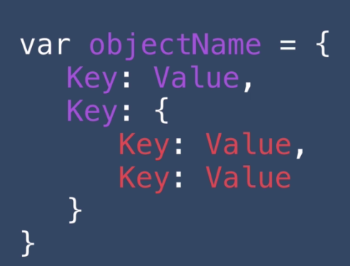

**Solution:**

app.post("/compose", function(req, res){

//console.log(req.body.postTitle);

//console.log(req.body.postBody);

const post = {

title:req.body.postTitle,

content: req.body.postBody

};

});